COURSE CODE: ECA5604
NAME: B.vennela

EXPERIMENT:5 MIMO System Simulation with BER Analysis Date
Obj : 1
AIM:
To simulate a MIMO (Multiple Input Multiple Output) wireless communication system and analyze its performance in terms of Bit Error Rate (BER), Signal-to-Noise Ratio (SNR), and Channel Capacity (bps/Hz) using MATLAB.
Output:
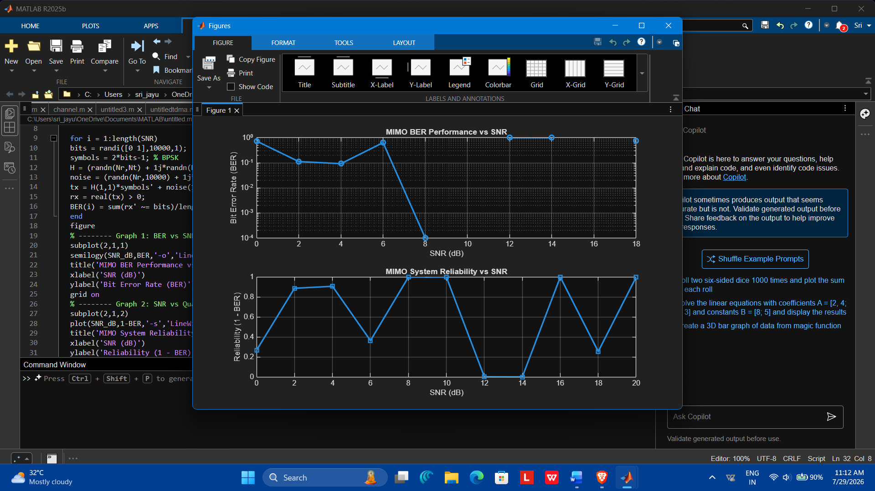
Obj :2
Aim : To analyze the impact of Signal-to-Noise Ratio (SNR in dB) on the reliability and
quality of MIMO communication.
O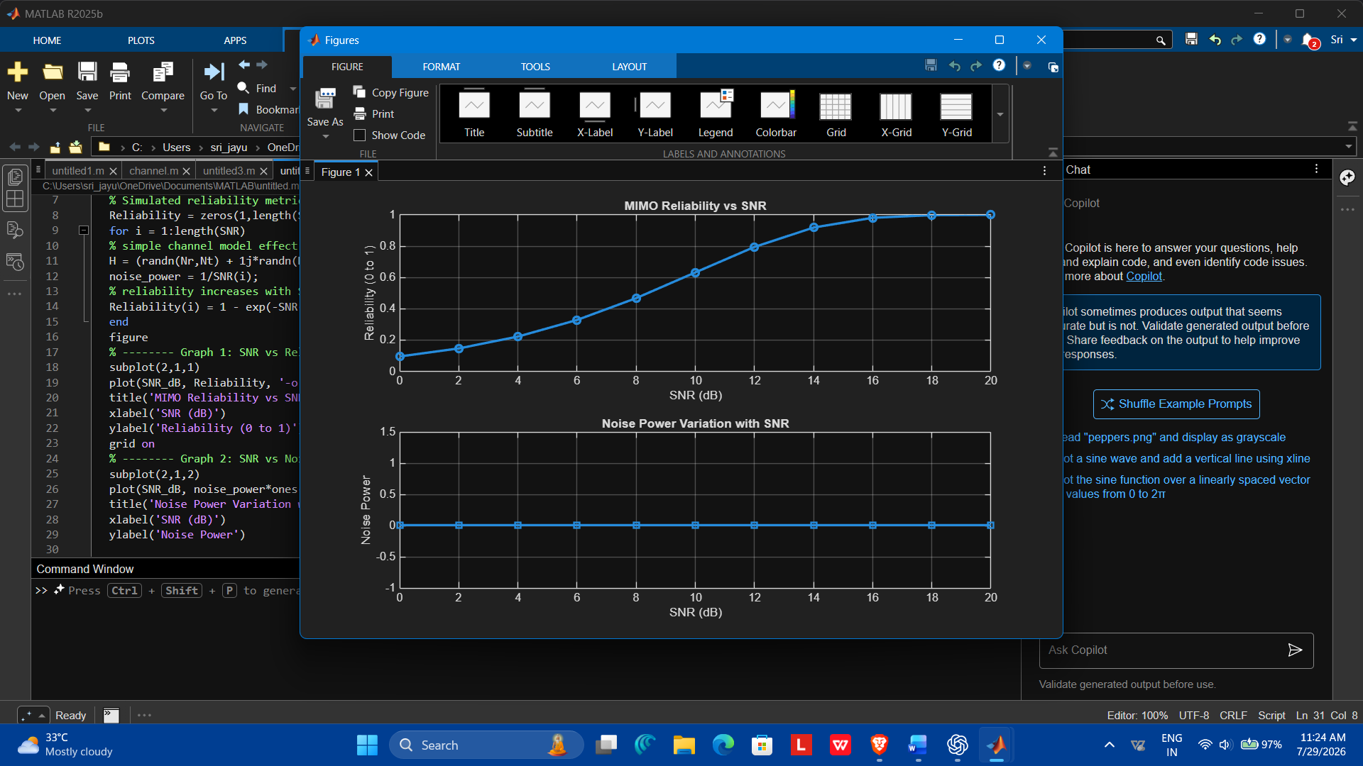
Result : These are the mathematical formulas corresponding to the MATLAB simulation you provided.
Obj :3
To compute the Channel Capacity (bps/Hz) and study how MIMO improves spectral
efficiency compared to single antenna systems.
Output : 